PRE-REQUISITES

**Install Python Packages**

|  |  |
| --- | --- |
| Team ID | PNT2022TMID08090 |
| Project Name | University Admit Eligibility Predictor |

**Step 1 :** Open the anaconda navigator

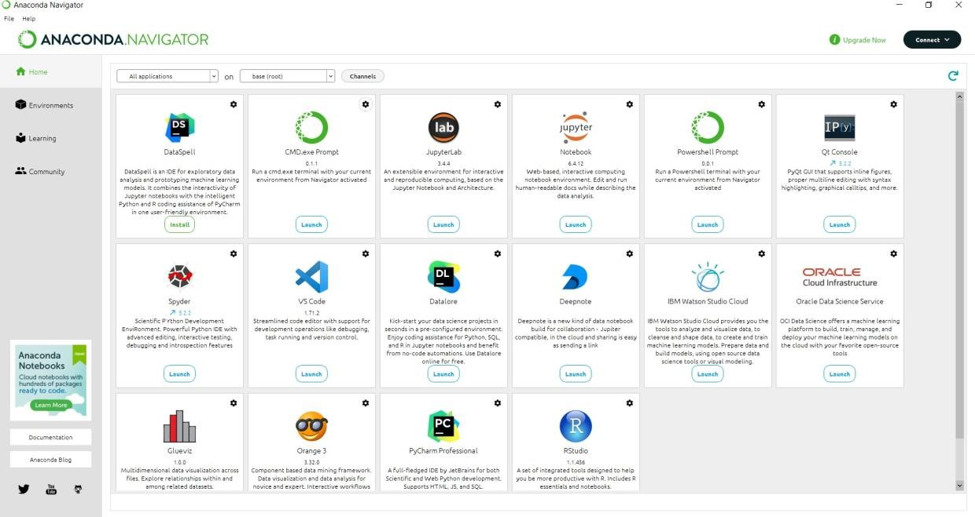

**Step 2 :** Open the Command prompt in the Anaconda navigator

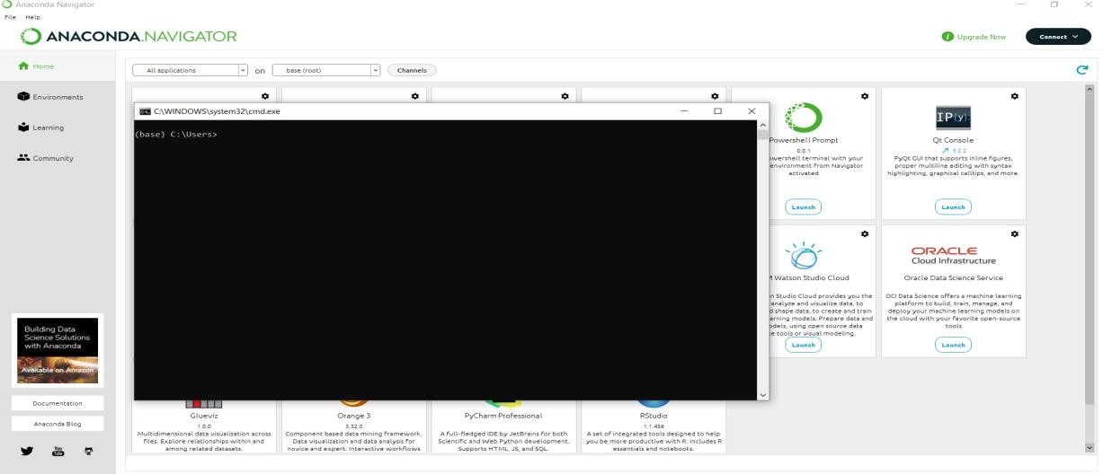

**Step 3 :** To install the numpy package enter the command in the CMD.exe Command : pip install numpy

# Numpy :

This package is used to perform numerical computations. NumPy is used for working with arrays. NumPy is short for "Numerical Python”.

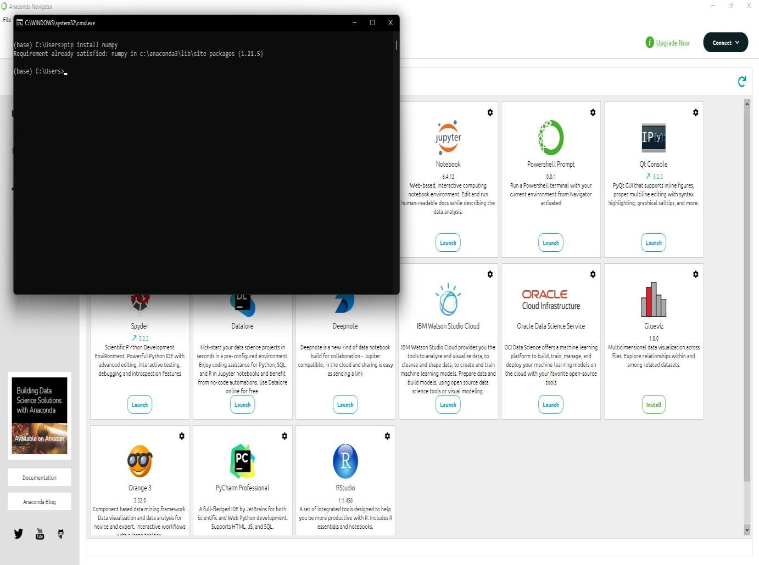

**Step 4 :** To install the PANDAS package type the following command Command : pip install pandas

# Pandas :

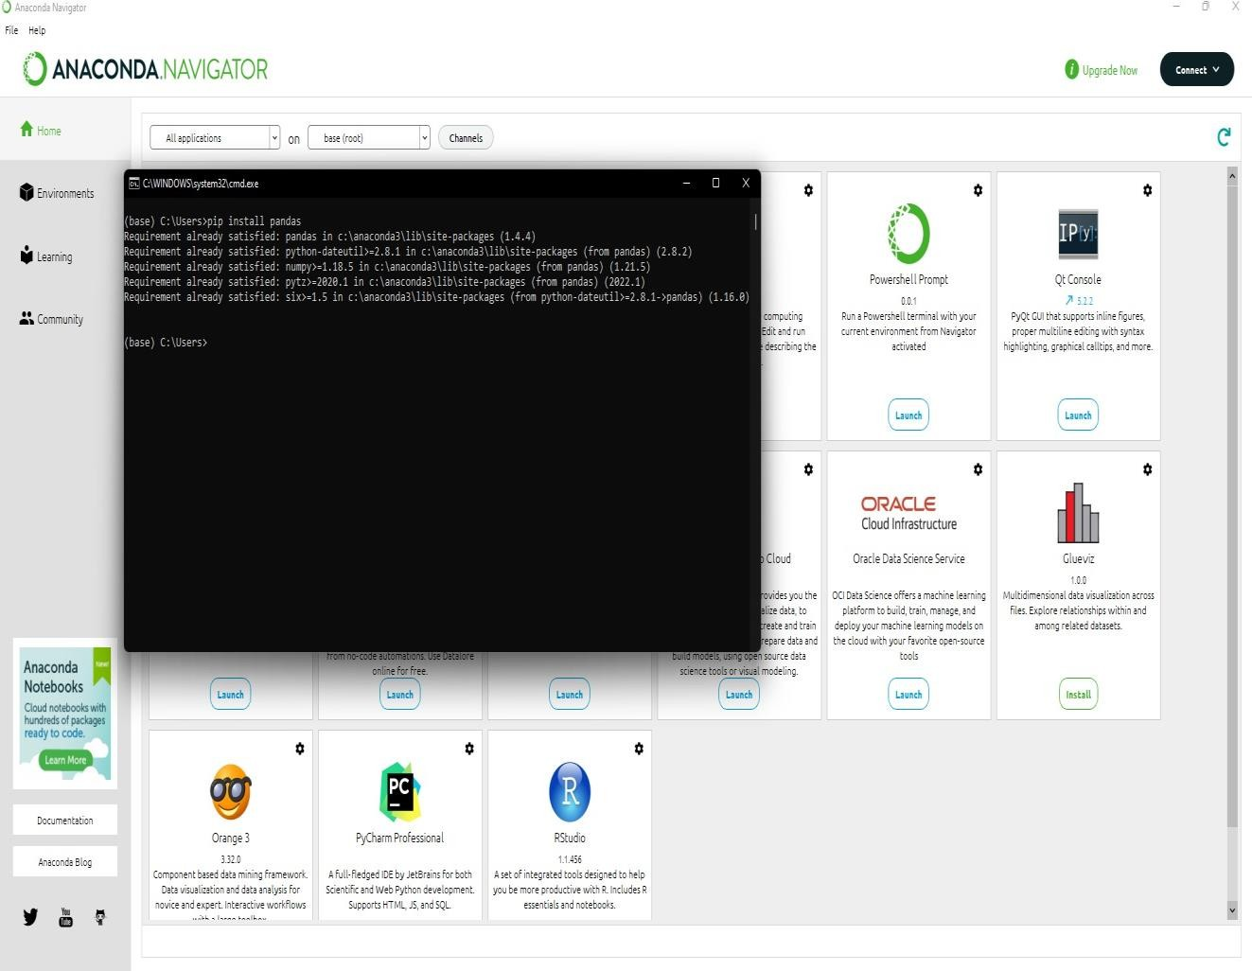This package is used for data science/data analysis and machine learning tasks . Pandas is used to analyze

data. Pandas stands for “Python Data Analysis Library

**Step 5 :** To install the MATPLOTLIB package type the following command Command : pip install matplotlib

# Matplotlib :

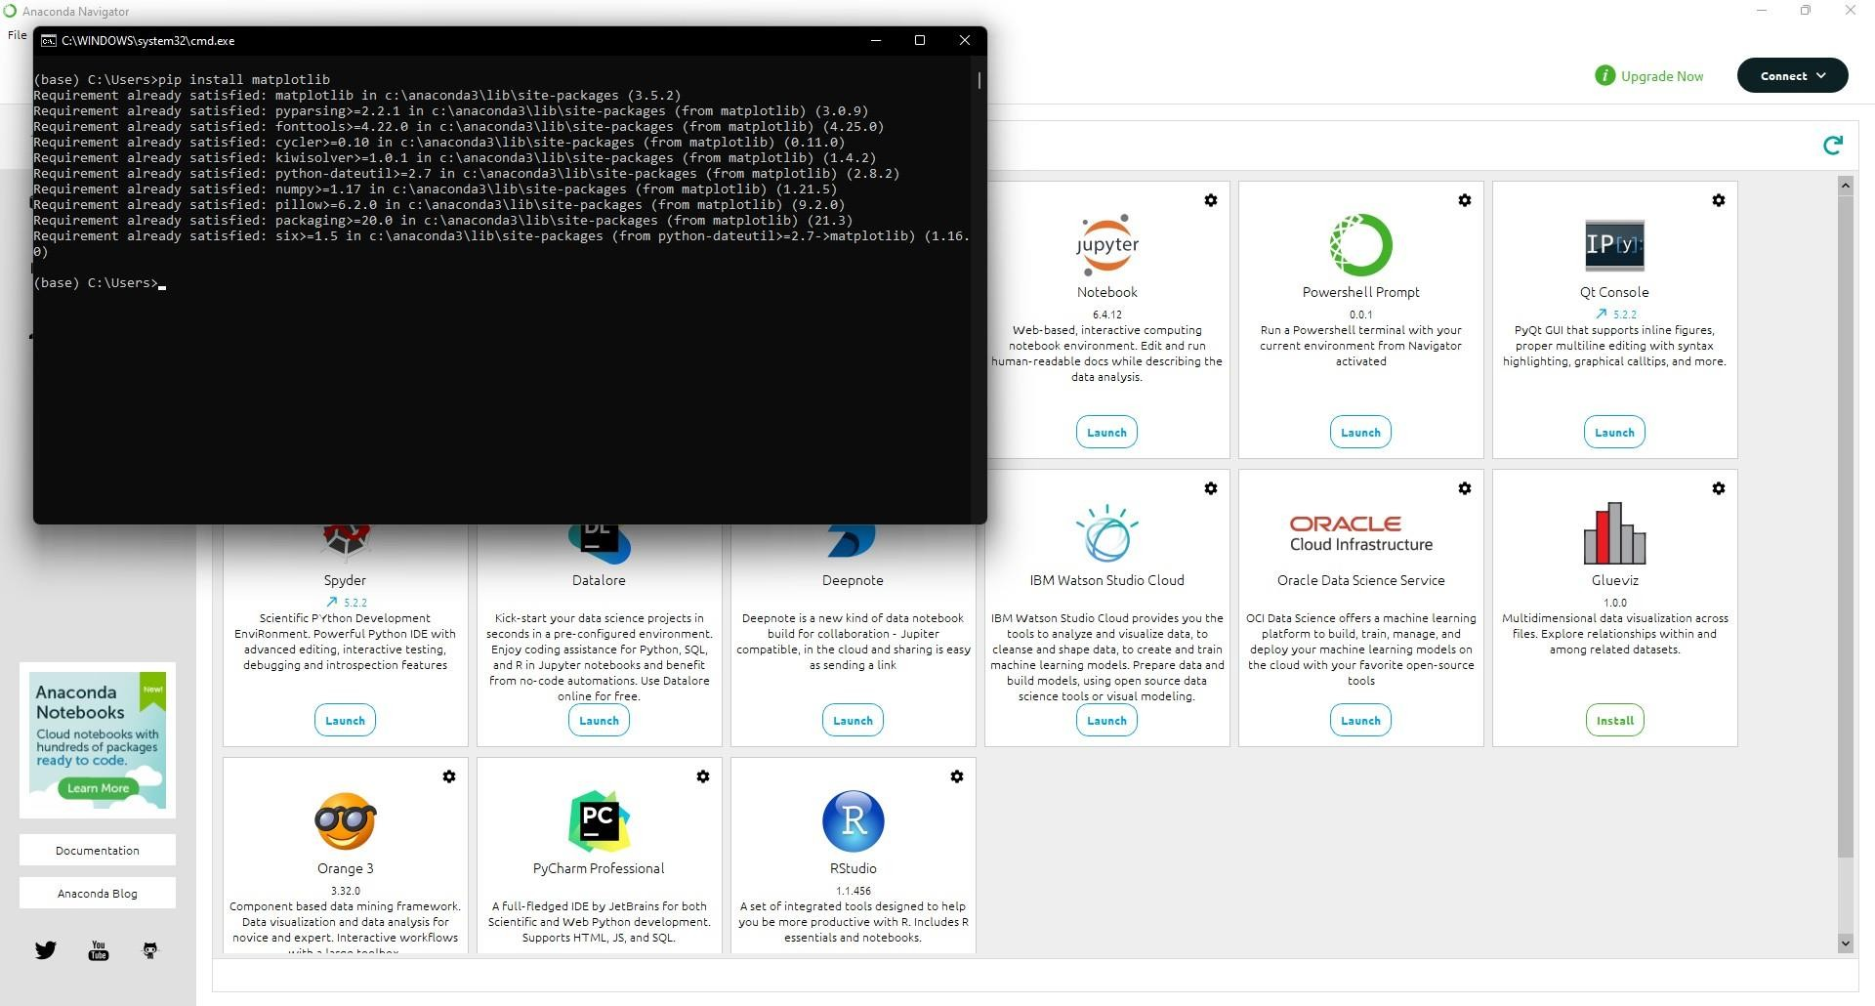This package is used for creating static, animated, and interactive visualizations in Python.

**Step 6 :** To install the SCIKIT-LEARN package type the following command Command : pip install scikit-learn

# Scikit-Learn :

This package provides a selection of efficient tools for machine learning and statistical modeling including classification, regression, clustering and dimensionality reduction via a consistent interface in Python.

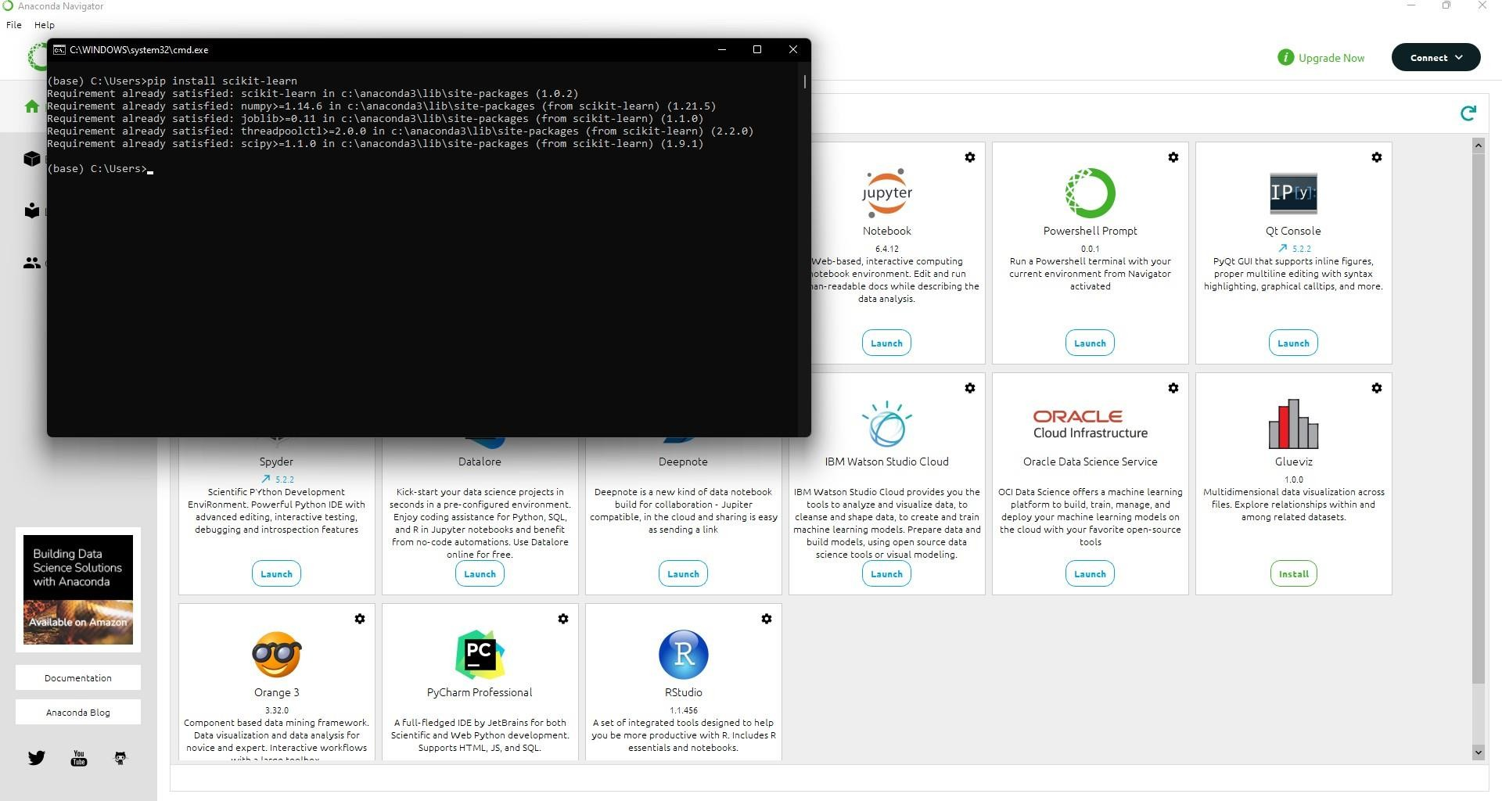

**Step 7 :** To install the FLASK package type the following command Command : pip install flask

# Flask :

This package is used for developing web applications using python, implemented on Werkzeug and Jinja2.

